Student Name ______________________________________ Section ___ Date _________

#### Installing Android Studio

The following steps will guide you the installation of Android Studio.

**STEP 1 Visit the Android Studio Web Site for your download**

Open the following URL on your Web browser.

<https://developer.android.com/studio/index.html>

Click on the download link as shown below

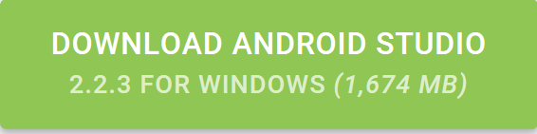

Accept the EULA agreement to start your download bundle (Windows approx. size is 1.63gb).

Click the Save File button on the pop up window to save the file to your designated download folder.

**STEP 2 Installing your bundle**

1. Double-click your downloaded executable (.exe file) to start the install wizard.
2. Make sure to choose all components in your set up including the SDK and Virtual Device as shown below.

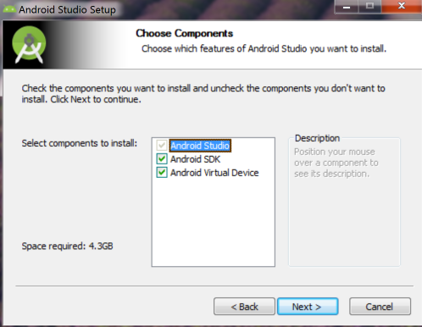

Accept as the next step te License Agreement.

1. Choose the default locations for your install (shown below) if you desire.

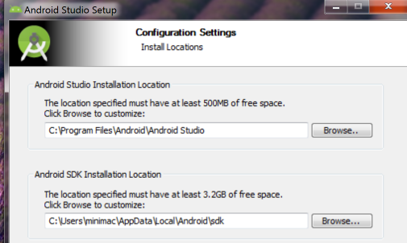

It doesn’t hurt to make a note of the name and location in which it saves the SDK on your system—you may need to refer to the SDK directory later, when using the SDK tools from the command line, loading plugins, etc.

Choose as the next step, a choice Startup Folder.

**STEP 3 Doing updates**

Start up Studio and perform updates.

When you start Studio you should automatically get an update message as follows on your screen

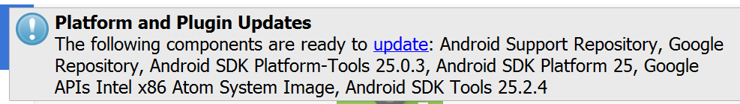

Click the update link and walk through the steps as follows:

Click the Update Now button as shown below.

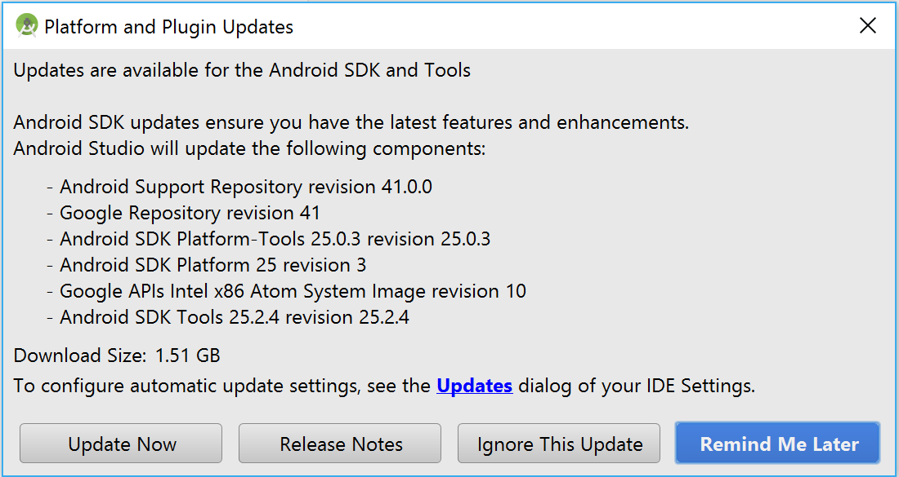

Next agree to the Terms and Conditions

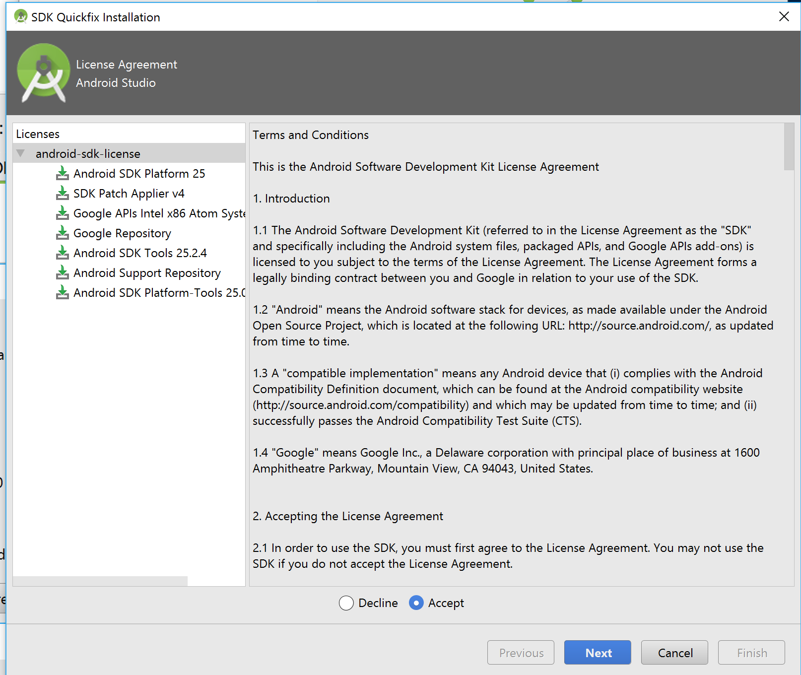

Note what is being installed…

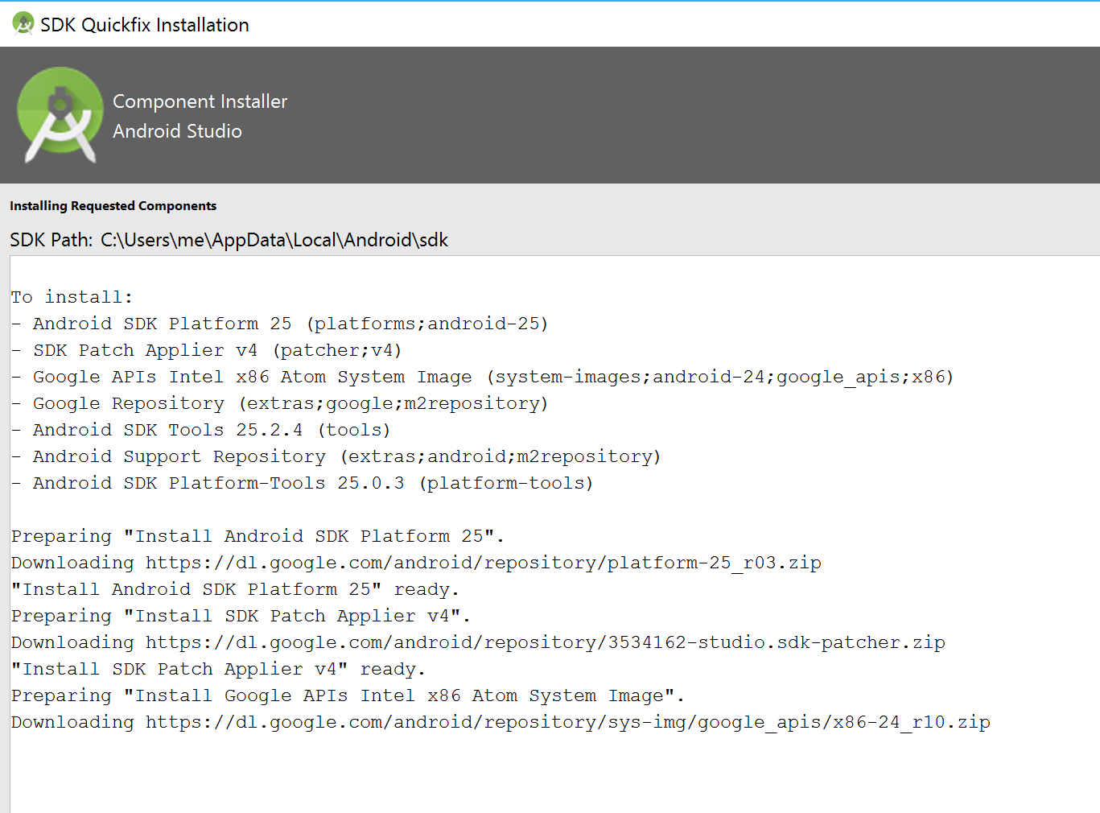

Click Finish when complete!

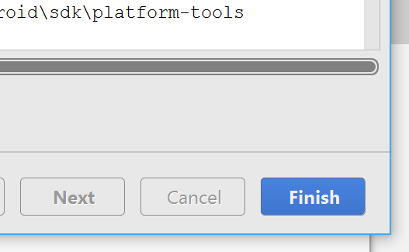

Once complete, click Finish. You are now taken to a Welcome screen! Congratulations on

your install!

Note- check for updates periodically as some tools / packages for the SDK may still be needed or are needed to update your system (updates never hurt)! To perform any updates navigate to Tools>Android>SDK Manager.

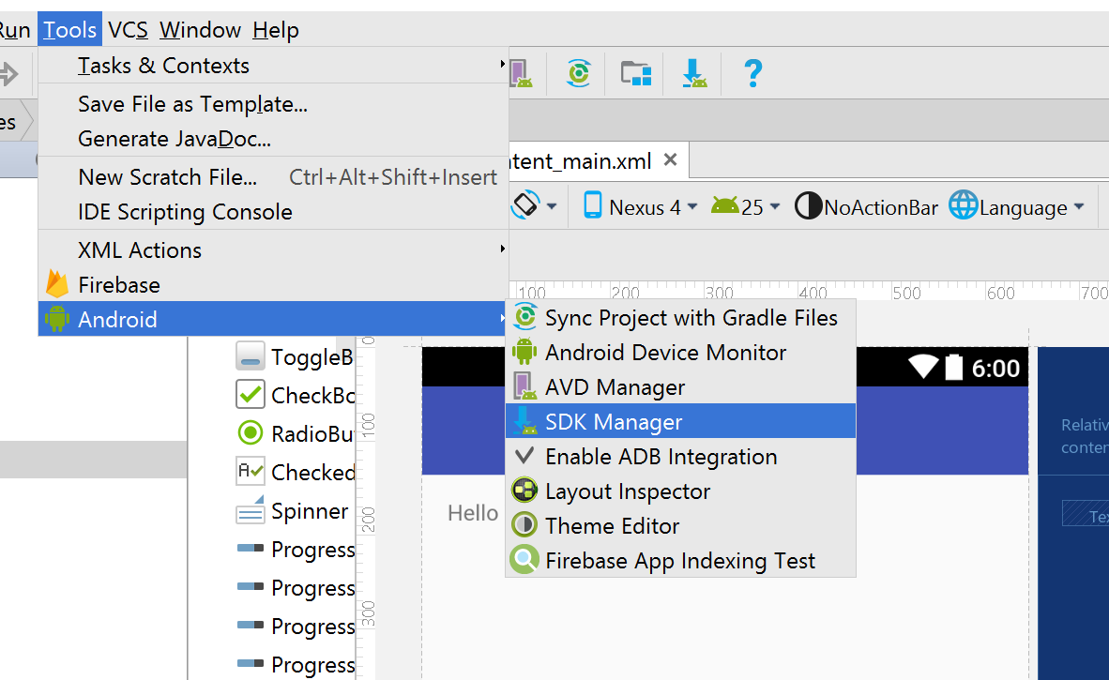

When confronted with the SDK Manager Default Settings window, click on Launch Standalone

SDK Manager (snapshot to link follows). From there choose important packages that need

updating such as Google USB Driver (under Extras) for instance.

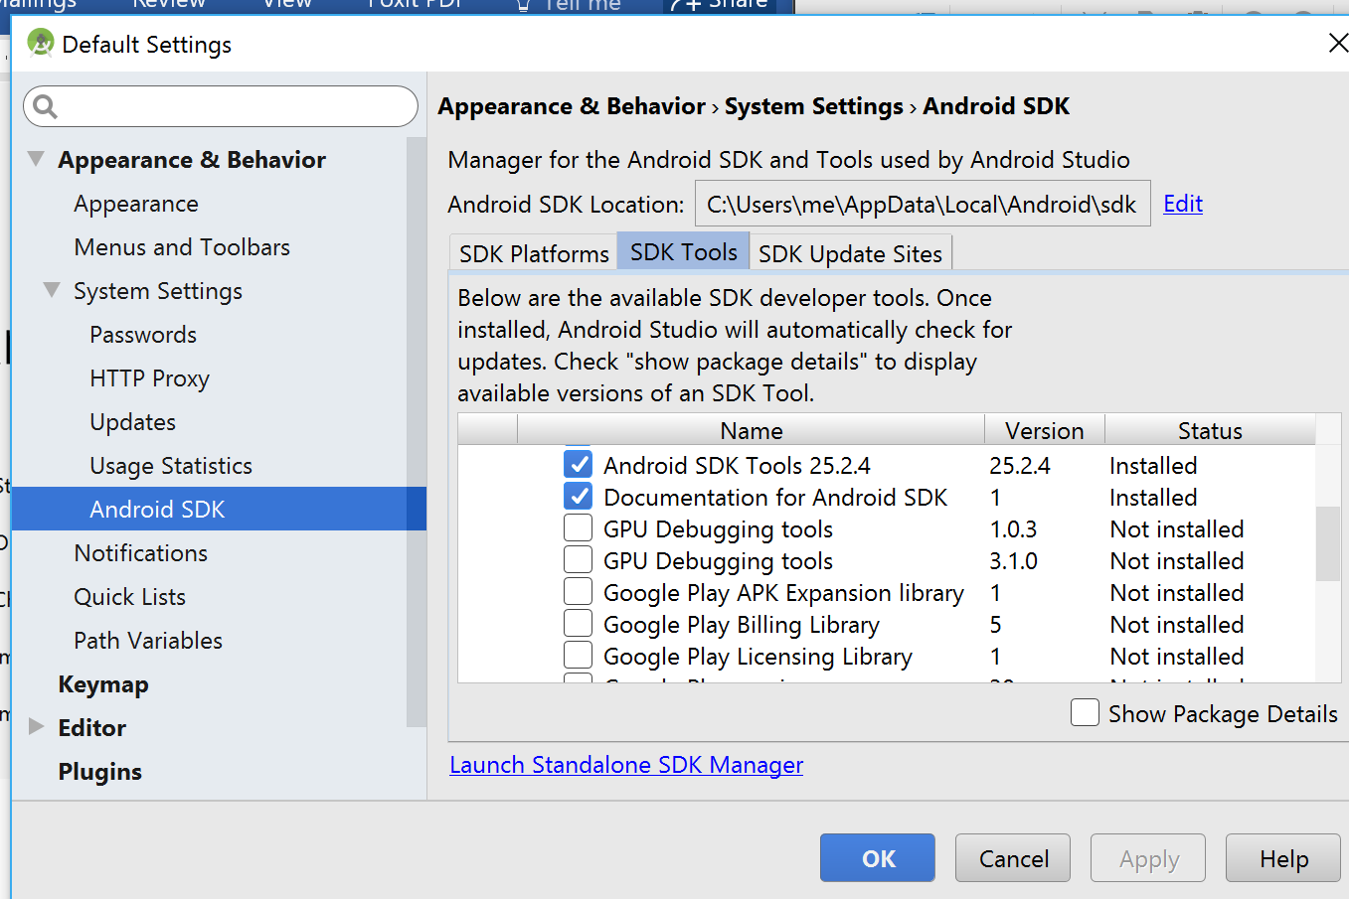

When ready to install your updates, click the **Install xx packages** button on the right

side as shown below.

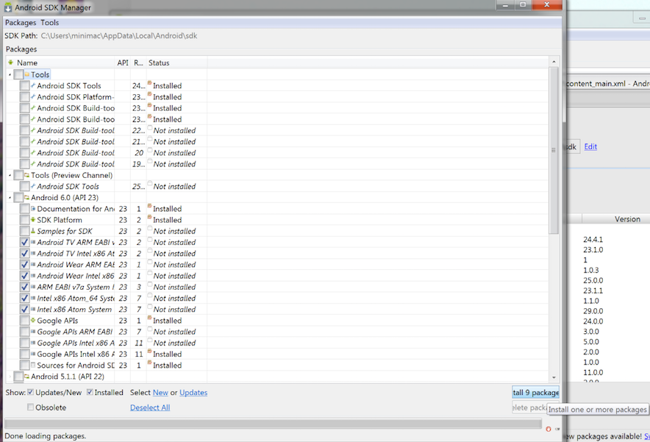

Accept the license at this point and click Install xx packages to start your updates. Close

out of your Manager when complete.

**For more information please reference the following sites:**

[**http://developer.android.com/sdk/index.html**](http://developer.android.com/sdk/index.html)

[**https://developer.android.com/about/versions/marshmallow**](https://developer.android.com/about/versions/marshmallow)